Team 302

Sam Kohler, Tyler Winder, Jose Nava, T.J.

Design Ideation

EGR 314

**Brainstorming**

Team 302 brainstormed ideas in order to come up with a product that would use at least two different weather sensors and contain a motor or a serial actuator. The following are the ideas that were generated.

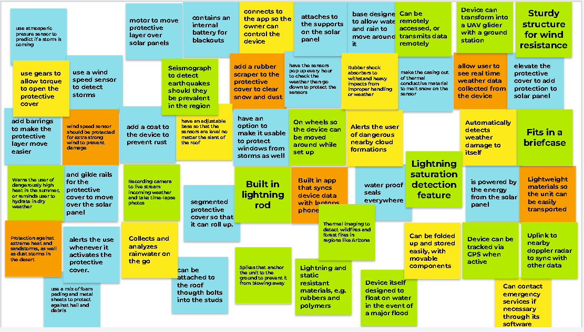

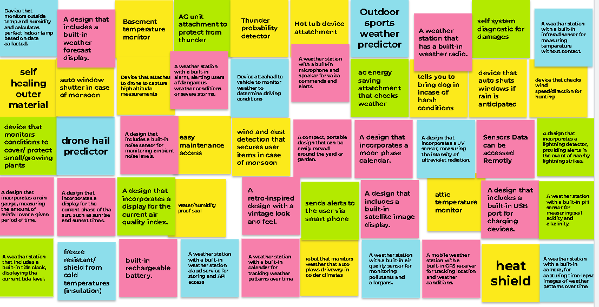

**Sorting**

After brainstorming the team noticed that the ideas worked together to form groups. The team sorted these ideas into four groups. The results of which are shown below.

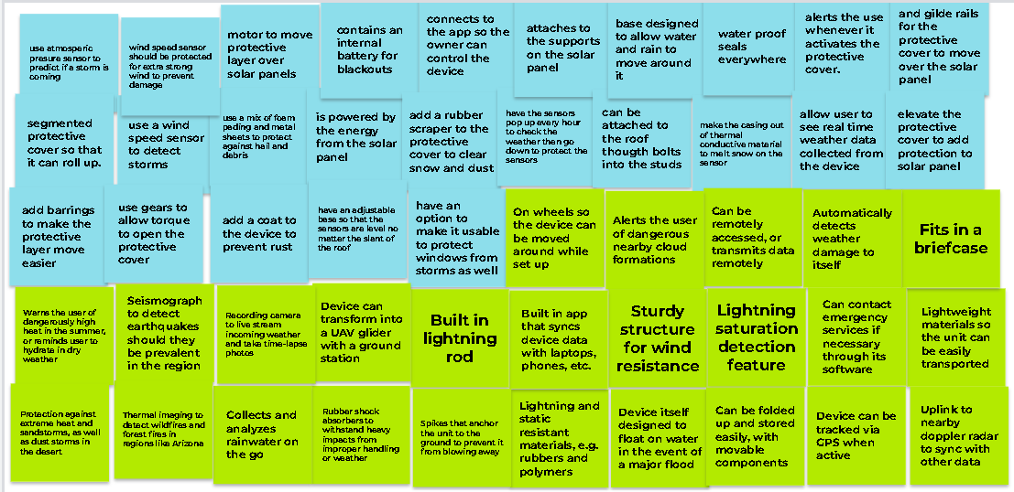

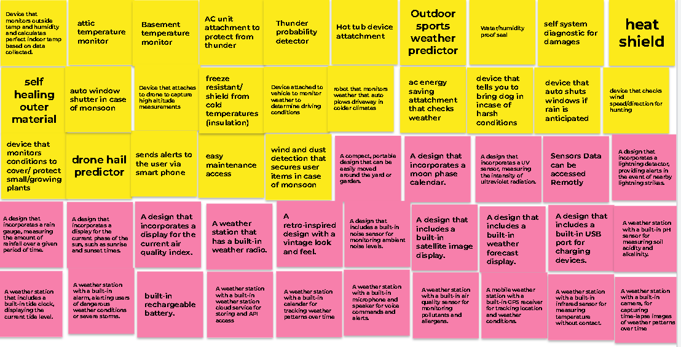

**Design drawings**

The team then used the ideas in these groups to convert them into engineering drawings to better understand the designs. The team was able to turn their ideas into three different drawings.

1. **Solar panel protection**

This first idea is a self contained device that is installed next to the solar panel that when it detects conditions that cause storms that would produce strong winds or hail. This device will then activate a motor that will unroll a stored protective covering over the solar panel inorder to protect it from hail and other storm debris. The device also has a retractable top that will cover the sensors and protect them from hail, debris, and strong winds. The lid will raise up and allow the sensors to detect the weather conditions every hour before the lid will lower again. The design can be seen below.

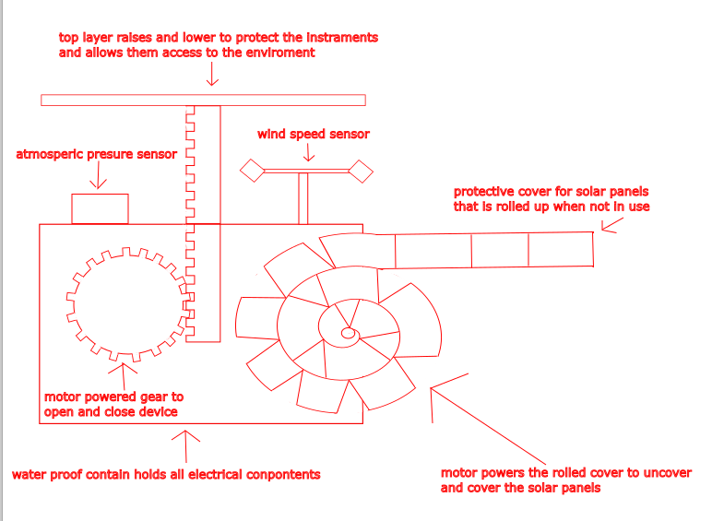

1. **Weather Station Glider**

A weather station glider is a type of unmanned aerial vehicle (UAV) that is specifically designed for collecting weather data. These gliders can fly at high altitudes and over long distances, allowing them to gather information on temperature, humidity. It is typically used in remote or hard-to-reach areas, and can provide valuable data for weather forecasting, climate research, and other applications.

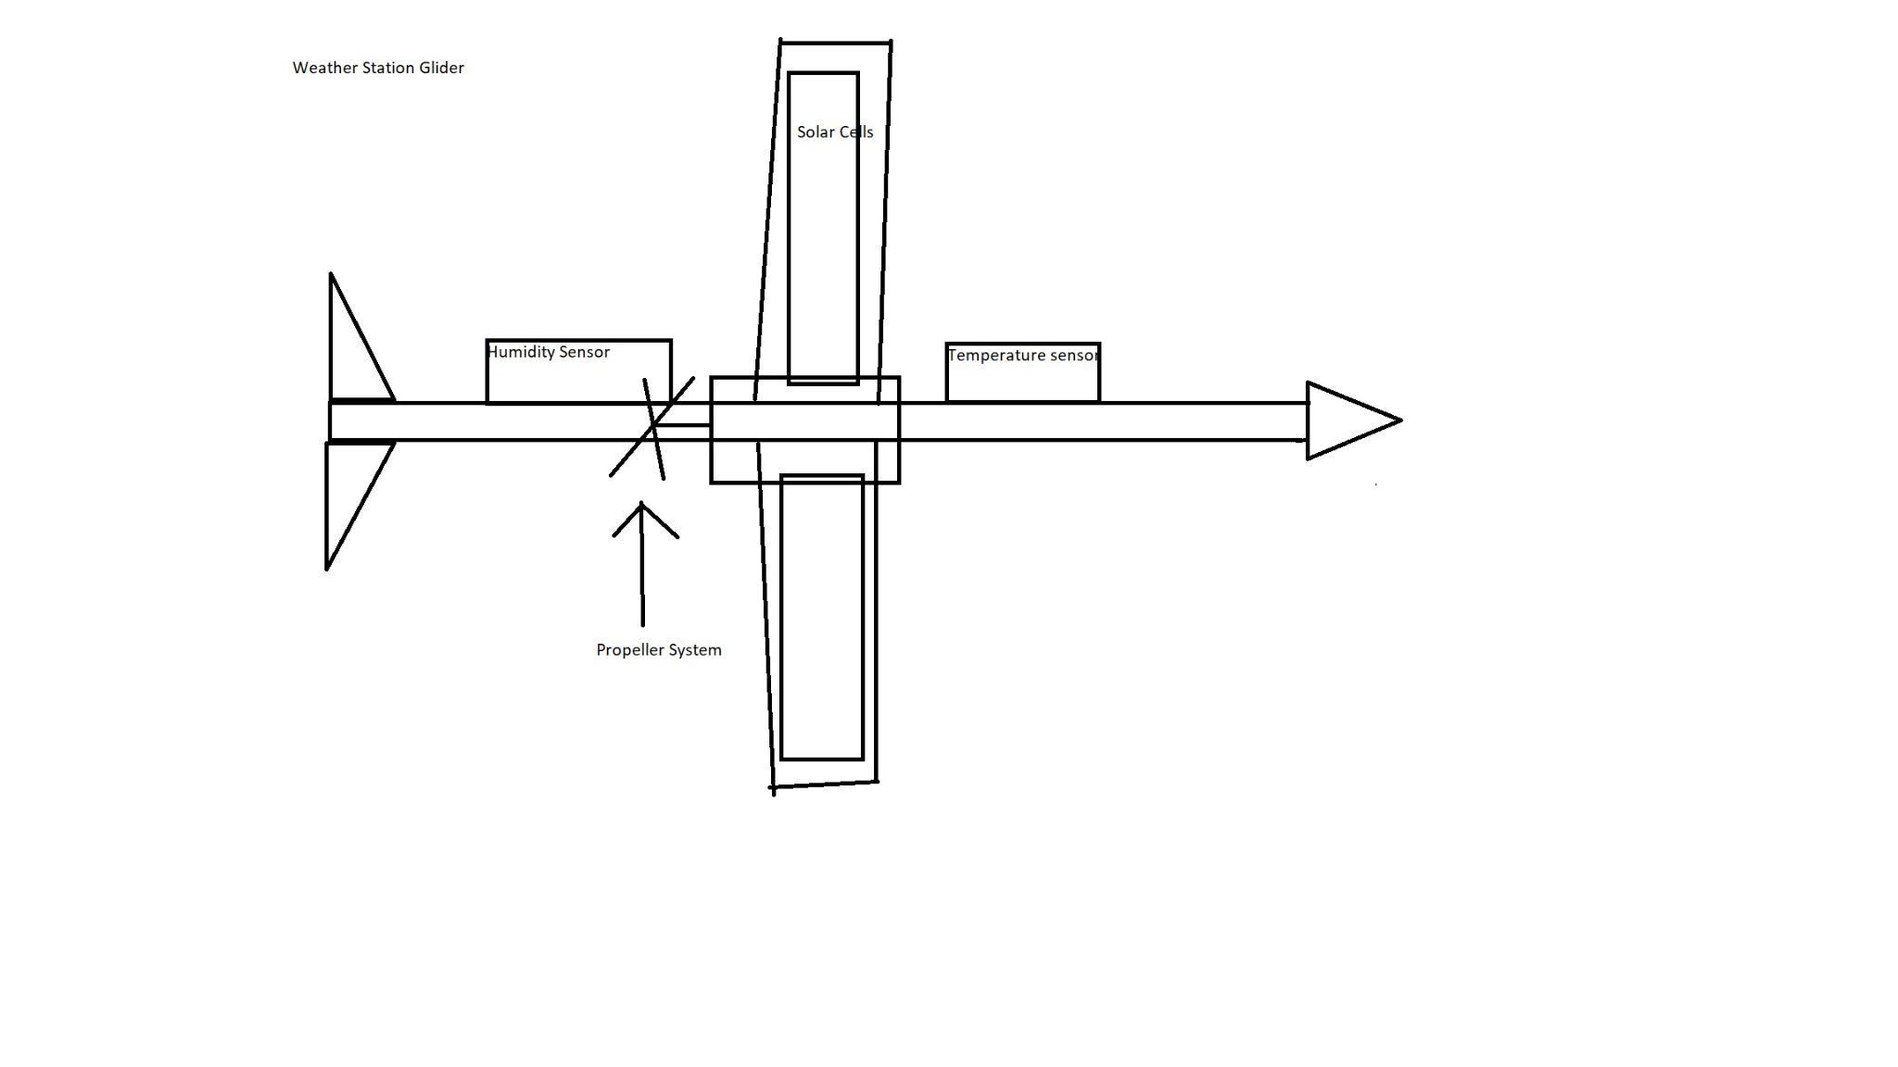

1. **Automated AC Unit Cover**

This idea is a protective cover that is deployed to cover the filter opening of a typical ac unit during a monsoon or storm in order to reduce the amount of dust that may be forced into the unit. The cover will use a material that does not restrict air flow but will restrict particles from entering the system. Similarly, it would deploy during a storm to avoid anything else from entering the AC system. When the reservoir fills with X amount of liquid or fills too quickly the cover will deploy in order to cover the vent opening. Similarly if the device senses wind speed that exceeds X amount will deploy the cover until it reaches an acceptable level. This will prevent damages or costly repairs.

